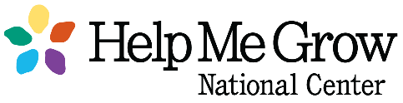
Implementation Affiliates,

Please see the link below to access the 2021 Sustainability Assessment (SA). Because you have demonstrated implementation of the HMG model in a previous FA, you are receiving an adapted (and condensed!) assessment.

Important: The survey settings in SurveyMonkey will enable you to start, stop, and later return to your saved answers to continue completing the survey, provided you access your survey link from the same computer and using the same internet browser. Only completed pages will be saved. If you stop midway through a section those responses will not save. By pressing “Next” on the survey you have saved your responses to that section.

In addition to verifying your maintenance of the 16 key activities, this assessment will ask a variety of questions that continue to explore themes associated with sustainability of the HMG model. Please note that Impact Indicators are expected to be reported in this year’s assessment. You will be asked to report data from the previous twelve months (September 2020-August 2021). If you have any questions regarding the Impact Indicators, please reference the HMG Guidelines for Data Collection and Reporting. You will also find a PDF of that assessment attached that we encourage you look at as you prepare your responses. The Sustainability Assessment should be completed no later than October 31st . If you have any questions throughout this process, please feel free to reach out to me directly.

Sustainability Assessment link: https://www.surveymonkey.com/r/HMGSustainability2021

Best,
Cassie Therriault
Business & Administrative Coordinator
Help Me Grow National Center
Connecticut Children’s
Office for Community Child Health
Phone: (860) 837-5712

