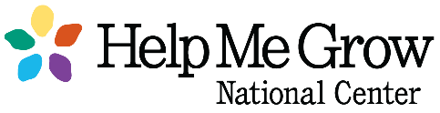
Dear HMG System Leads,

Please see the link below to access this year’s HMG Fidelity Assessment. We encourage you to collaborate with relevant partners when completing this assessment to ensure that the most accurate information is submitted. In addition, as a result of the feedback we received from affiliates completing last year’s assessment, the National Center has made several changes to improve and streamline the annual reporting process, these changes are summarized and attached to this email.

Important: The settings in SurveyMonkey will enable you to start, stop, and later return to your saved answers to continue completing the survey, provided you access your survey link from the same computer and using the same internet browser. Only completed pages will be saved. If you stop midway through a section those responses will not save. By pressing “Next” on the survey you have saved your responses to that section.

As with previous years, the Fidelity Assessment includes questions specific to HMG Impact Indicators. You will be asked to report data from the previous twelve months (September 2020-August 2021). If you have any questions regarding the Impact Indicators, please reference the HMG Guidelines for Data Collection and Reporting. The Fidelity Assessment should be completed no later than Sunday, October 31, 2021.

Fidelity Assessment 2021 Link: https://www.surveymonkey.com/r/HMG2021Fidelity

Best,
Cassandra Therriault, MPH
Business & Administrative Coordinator
Help Me Grow National Center
Connecticut Children’s
Office for Community Child Health
Phone: (860) 837-5712

