Help Me Grow System Model

Core Components & Key Activities

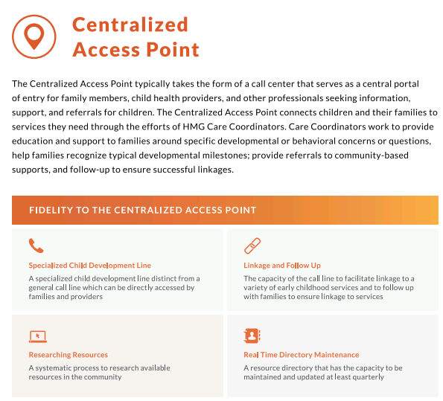
Helpful resources to start with:
- Get to know three different HMG affiliates’ approaches to the Centralized Access Point
- How does a community new to HMG decide how their CAP is going to look? See how two did it here.
- Get to know the basics of what we mean when we talk about HMG Care Coordination.
- Sometimes a family’s needs aren’t black and white. See how three affiliates go about identifying needs when they aren’t so clear here.

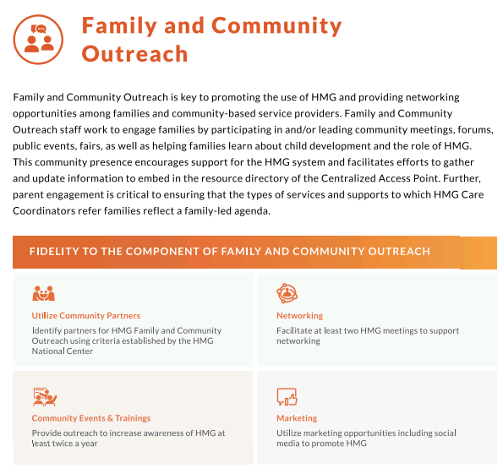

Helpful resources to start with:
- Get to know two different HMG affiliates’ approaches to Family & Community Outreach
- Be sure to read (and use) the HMG Framing Toolkit, a presentation about the Toolkit, and see how one affiliate is using the Framing Toolkit to build partners among community-based providers
- Three affiliates’ approaches to HMG networking meetings

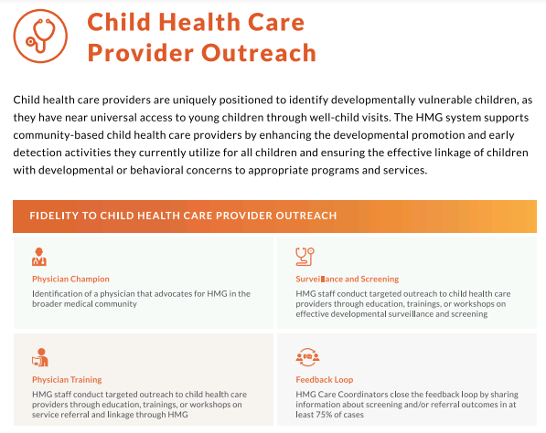

Helpful resources to start with:
- A recent and robust overview of HMG Child Health Provider Outreach from the 2020 HMG Forum (session starts at minute 3:00, use password HMGForumDay3! to view)
- Get to know two different HMG affiliates’ approaches to Child Health Care Provider Outreach
- What does it mean to include child health providers as key partners in an early childhood system
- Hear the HMG National Center’s philosophy that screening is only helpful if it is embedded in an efficient, effective early childhood system

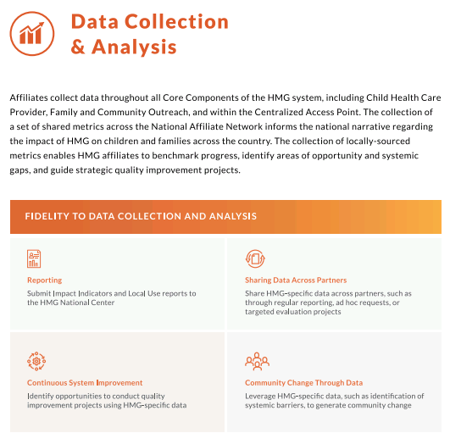

Helpful resources to start with:
- HMG Data Collection & Reporting Guidelines
- Two examples of sophisticated, local, evaluative HMG analysis: one from a long-standing affiliate and one from a relatively new affiliate
- An incredible example of one affiliate using data collected through HMG to guide system-level change
- HMG National Center’s 2019 annual report (also a great resource to get a better sense of how affiliates across the Network are implementing the Model)

