WIC DEVELOPMENTAL CHECKLIST PROJECT
eXECUTIVE overview
Project Outcomes
The project has three outcomes:
Parents and caregivers are aware of developmental milestones, the importance of acting on concerns, and the availability of support & resources through HMG
WIC staff are committed to the early identification of developmental concerns and the successful implementation of the project
The number of referrals to HMG from WIC offices and clients increases

Project Summary
In 2014, Help Me Grow Alameda County (HMG) partnered with Alameda County Public Health Women, Infants and Children (WIC) to introduce the use of developmental checklists at WIC sites in Alameda County, California. Looking to enhance its support to families regarding child development and school readiness, Alameda County Public Health WIC approached Help Me Grow Alameda County for assistance and collaboration. Together, the agencies planned the WIC Developmental Milestone Checklist project, which was piloted at the Eastmont WIC office in East Oakland.
2
1
Project Model
The WIC Developmental Checklist Project replicated aspects of a model program developed in Saint Louis, MO utilizing developmental checklists from the Centers for Disease and Prevention Control’s (CDC) “Learn the Signs. Act Early.” (LTSAE) campaign, together with wall and floor graphics that support the campaign. In Alameda County, the checklists were available in English and Spanish for 10 age intervals and included HMG program information. WIC staff were engaged throughout project development and design which included training on child development and project implementation.
3

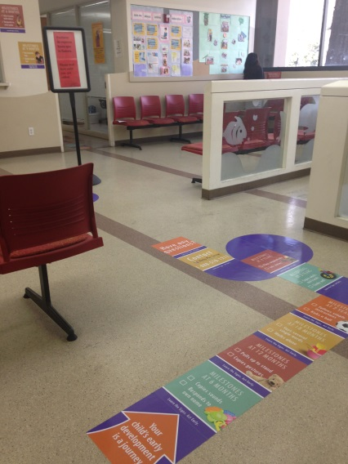
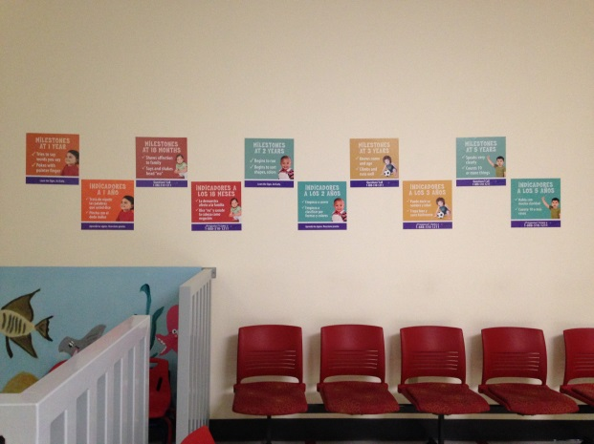
WIC Eastmont launched the project in November 2014. After caregivers completed the checklist WIC staff used decision tree process resulting in one of two recommendations: when no concerns were raised by the checklist or the parent, staff encouraged caregivers to share the results with their pediatric provider, when concerns were raised WIC staff recommended a referral to Help Me Grow and/or discussion with their pediatrician. Help Me Grow was offered as a resource to all parents
Success of WIC Developmental Checklist Project
Six months after the launch of the project at the Eastmont WIC office, both parents (n=90) and WIC staff (n=11) were surveyed to determine if project outcomes were achieved.
99%  felt the checklist was helpful | 68%  had heard the term, “developmental milestones” | 62%  learned something new from the checklist
80%  felt the checklists assisted them in supporting families | 100%  feel comfortable talking to parents when the checklist reflects a concern | 100%  agree it is important to identify developmental concerns early
WIC PARTICIPANTS

WIC
STAFF

Family Knowledge Gained from Checklists
Participants learned about their child’s development, about how to support their child’s growth, and about general child development and developmental milestones.
“[I learned about] the signs according to my child’s age, and [to] be on the lookout if something is different.”
[I’m] do[ing] more activities with my children to help them grow.”
”

“[I learned] how my child is developing and that she’s doing what she should at her age.”

Referrals to HMG
Before the project started, Eastmont WIC had referred 36 children to HMG from November 2013 through October 2014. During the 12 months following the implementation of this project at the Eastmont WIC site (November 2014-2015), Eastmont WIC staff referred 121 children, a 236% increase compared to the previous year of partnership. In addition, 10 parents from Oakland called HMG on their own and said they had heard about HMG from their WIC office.
Project Expansion
There are 17 WIC offices in the county. Since piloting the project at the Eastmont WIC office, the project has expanded to include 5 additional WIC offices. Planning is underway to expand to XX additional sites in the future. HMG will evaluate all participating WIC sites approximately six months after participation begins to assess outcomes across all sites and support the success of the project.
For the full report, see “WIC Developmental Checklist Project Evaluation available at www.first5alameda.org. For more information about the project, contact Angelina Ahedo, Help Me Grow Prevention Manager at Angelina.ahedo@first5alameda.org or 510-227-6943.

Farmer, J.E., Dunne, K., & Walker Falk, L. (2012). Implementation Manual. WIC Developmental Milestones Awareness Program. Learn the Signs. Act Early. A shared initiative between the Women, Infants and Children Nutrition Program and the University of Missouri. Program of the U.S. Department of Health and Human Services and the Centers for Disease Control and Prevention (grant number H6MMC11059).

