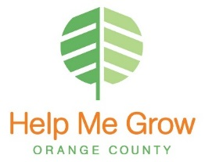

**Call Center Description**

**Call Center Type:** Inbound/2-1-1

**FTE:** 2.5

**Call Volume:** average 520 (IB/OB) per month

**Operational Since:** 2007

**Results:**

Goal of % under 15 was reached by 5th cycle

**Changes:**

1. Decrease amount of follow-ups per case

2. Move after-hours voicemail to main menu and remove reporting to %

3. Create menu options for new callers and those with an open case

4. Add part-time staff member during peak call hours

5. Add queue waiting promotions/blurbs

For more information, contact:

Rebecca Hernandez

Program Manager

949-267-0300

**Protective Factor Addressed:**

Parental Resilience

Concrete Support in Times of Need

Social Connections

Social & Emotional Competence of Children

**Knowledge of Parenting & Child Development**

**Aim:** HMG staff works collaboratively with parents to coordinate support for children’s development

**Measure:** To improve collaboration by having an abandonment call rate that stays on or below 15%

**Improvement Strategies**

**for the**

**Help Me Grow Call Center**

**Call Center Description**

**FTE:**

**Call Center Type:**

**Call Volume:**

**Operational Since:**